CodeKrafters SRM – Task 2

Core Security Concepts Explainer
Name: Tanisha C
Department: B.Tech CSE Core (1st year)
College: SRM Institute of Science and Technology, Ramapuram

Table of Contents
- Introduction
- Confidentiality
- Integrity
- Availability
- Authentication vs Authorization
- Encryption vs Hashing
- Conclusion

Introduction
Cybersecurity is not just about hackers or antivirus software. Every time we unlock our phone, log into a website, or pay online, security concepts work behind the scenes to protect our information.
This document explains five important cybersecurity concepts in simple language using real-life situations. Each section includes a practical example and a simple diagram to make the concept easier to understand.

Concept 1 – Confidentiality

What is Confidentiality?
Confidentiality means keeping information private so that only the right people can see it.
For example, your Instagram password should only be known by you. If someone else gets it, your private messages and account become exposed.

Real-World Scenario
Imagine SRM's student portal stores marks, attendance, and personal details.

- You log in using your student ID and password.
- The website shows only your information.
- Another student cannot view your marks.
Now imagine someone guesses your password.
They could:
- Read your personal information.
- Download your documents.
- Change your account settings.
Confidentiality has now been violated because private information became accessible to an unauthorized person.

Why It Matters
Without confidentiality:
- Personal data can be stolen.
- Financial information can leak.
- Privacy disappears.

Original Diagram

Figure 1: Only authorized users should access private information.

Concept 2 – Integrity

What is Integrity?
Integrity means making sure information remains correct and unchanged unless an authorized person edits it.
Think of it like submitting an assignment.

Real-World Scenario

You upload your assignment before the deadline.
The professor expects to receive exactly the same file.
Now imagine someone changes your PDF after uploading it.
Your original work has been altered.
Even though the file still exists, its integrity has been compromised because the information is no longer trustworthy.

Why It Matters
Integrity protects:
- Exam results
- Medical records
- Bank balances
- Official documents

Original Diagram

Figure 2: Data should not be altered without authorization.

Concept 3 – Availability

What is Availability?
Availability means systems should be accessible whenever users need them.
A secure system is useless if nobody can use it.

Real-World Scenario
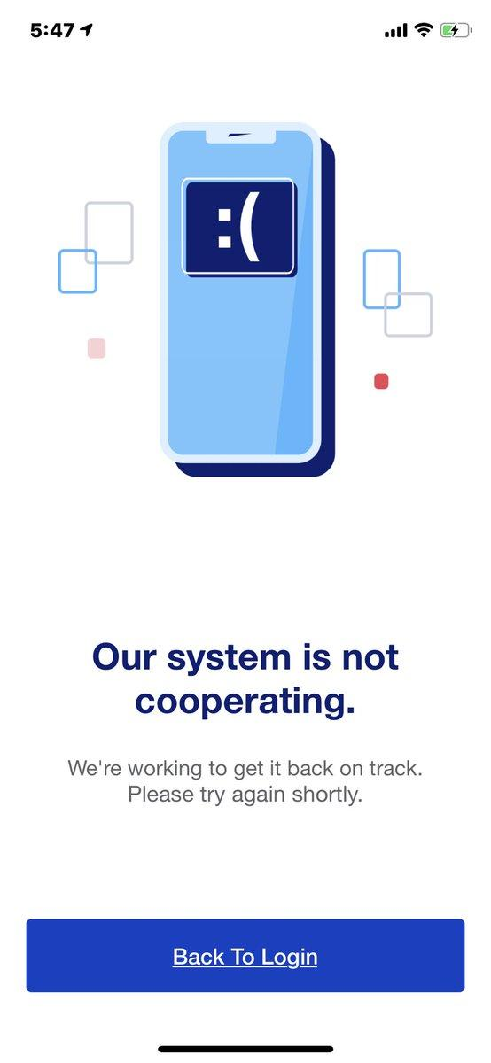
Imagine you're paying your college fees through online banking.
You enter all the details.
Suddenly the banking server crashes.
The website shows:
"Server unavailable."
Your money may be safe, but you cannot complete the payment.
Availability has failed because the service is temporarily inaccessible.

Why It Matters
Availability is essential for:
- Banking
- Hospitals
- Emergency services
- College portals

Original Diagram

Figure 3: A service must remain available for users.

Concept 4 – Authentication vs Authorization
These two words sound similar but mean different things.
Authentication: Proves who you are
Authorization: Decides what you can access

Authentication
Authentication happens first.
Examples include:
- Password
- Fingerprint
- Face Unlock
- OTP

Authorization
After identity is verified, the system decides what you're allowed to do.

Real-World Scenario

Imagine entering an office building.
Step 1: You swipe your ID card.
The security system verifies your identity.
This is authentication.
Step 2: You try entering the CEO's office.
Your ID opens only the employee area.
The CEO's room stays locked.
This is authorization.

Why It Matters
Without authentication:
- Anyone could pretend to be someone else.
Without authorization: 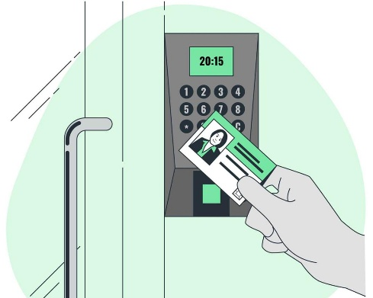
- Everyone would access everything.

Original Diagram

Figure 4: Identity verification happens before permission checks.

Concept 5 – Encryption vs Hashing
These are often confused because both change data, but they serve different purposes.
|
Encryption:
Can be reversed with a key
Protects secret information

Hashing:
Cannot be reversed
Verifies data

Real-World Scenario
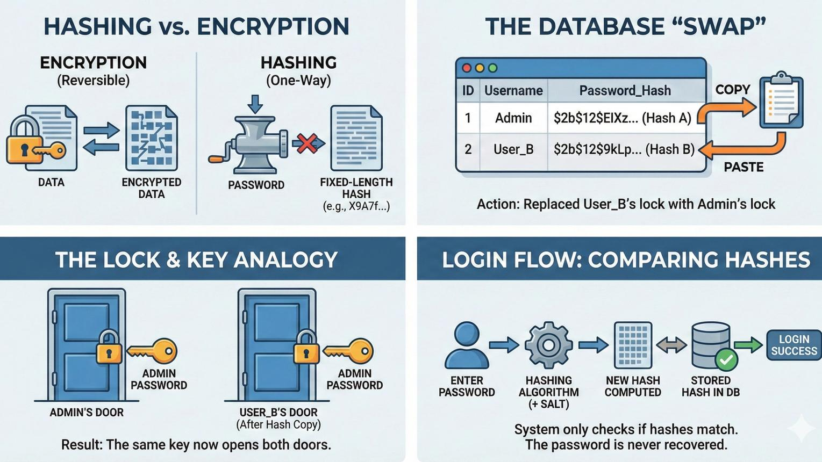
Imagine creating an account on a shopping website.

Encryption
When your payment information travels across the internet, it is encrypted.
Even if someone intercepts it, they cannot read it without the correct key.

Hashing
Your password is not stored as plain text.
Instead, the website stores a hash.
When you log in:
- Your password becomes a hash.
- The website compares it with the stored hash.
If both match, you are logged in.

Why It Matters
Encryption protects information during communication.
Hashing protects passwords inside databases.

Original Diagram

Figure 5: Encryption protects secrets, while hashing verifies data.

Conclusion
Cybersecurity is built on a few fundamental ideas that appear in everyday life. The CIA Triad ensures information stays private, accurate, and accessible. Authentication and authorization make sure the right people access the right resources, while encryption and hashing protect sensitive information in different ways. Understanding these concepts provides a strong foundation for learning more advanced cybersecurity topics.

